Moffat Bay Lodge
Module 6 Functional Test Plan
To complete the test case plan, fill out the information for Project, Course, Description and Date in the header below.
Project: | Moffat Bay Lodge
Course: | CSD 460
Description: | Room Reservation page and backend functional testing
Date: | 2026/09/12

TABLE OF CONTENTS
1. Room Available for Selected Dates
2. Insufficient Rooms Are Rejected
3. Reservation Creation Requires a Customer ID
4. Reservation Creation Succeeds for Open Dates

Developer documentation: include a test description, objective, developer name, date tested, and only Pass or Fail for each developer result. Peer QA documentation: use a different tester name, record the actual test date, enter only Pass or Fail for every step, and include a screenshot thumbnail showing the result of every step. Add 2–3 substantive sentences of QA comments for each test.

Test 1: Room Available for Selected Dates
Test 1 | Room Available for Selected Dates
 | Test Objective: Verify that a logged-in guest can select an available room type and valid future dates, receive an available result, and add the room to the reservation cart. | Developer: Rashai Robertson  Date tested: 2026/09/10 | Peer tester: Tiffany Davidson  Date tested: <2026/09/12>
Step | Action | Expected results | Developer pass/fail | Tester pass/fail + Screenshot
1 | Start MySQL in XAMPP, run `python src/api/startup_api.py`, and open http://127.0.0.1:8000/login.html. | The server starts successfully and the Moffat Bay login page loads with no broken page elements. | Pass | Pass  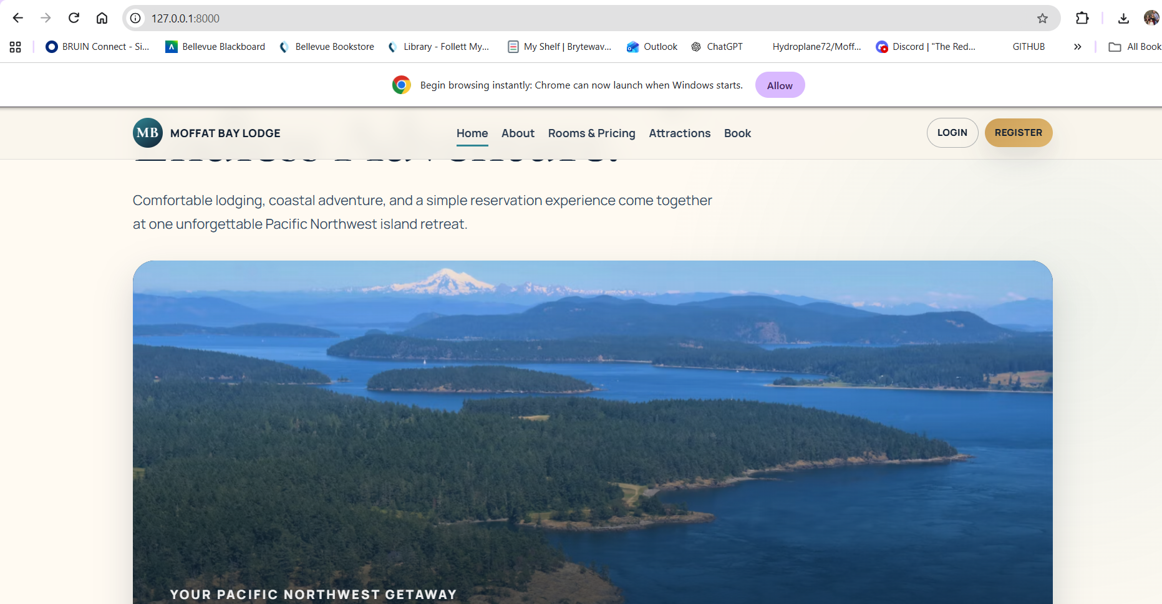
2 | Log in with the seeded demo account (demo@moffatbay.com / DemoPass1). | Login succeeds and the user is redirected to reservation.html with the reservation form visible. | Pass | Pass  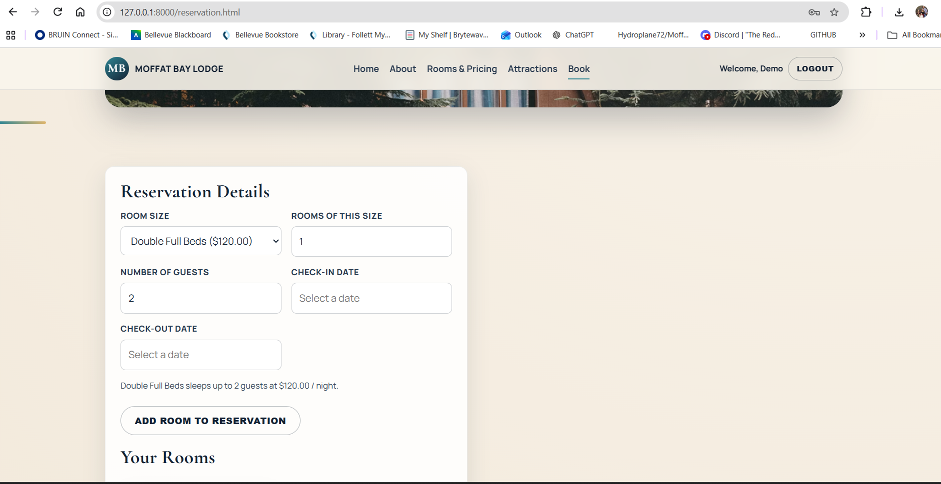
3 | Select 1 Queen room, 2 guests, and a valid future stay such as 2027-01-10 through 2027-01-12. | The selected room type, quantity, guest count, check-in date, and check-out date are accepted. | Pass | Pass  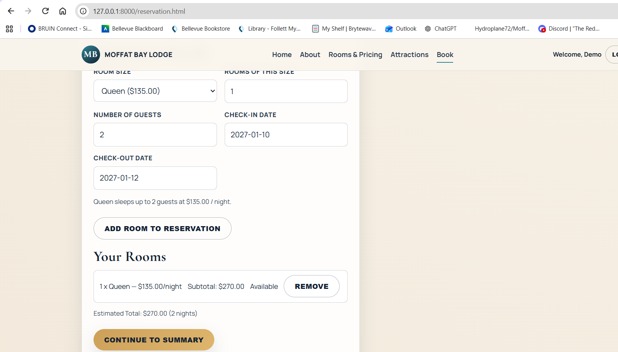
4 | Click “Add Room to Reservation” and review the cart. | The Queen room is added to Your Rooms as available and the “Continue to Summary” button becomes enabled. | Pass | Pass  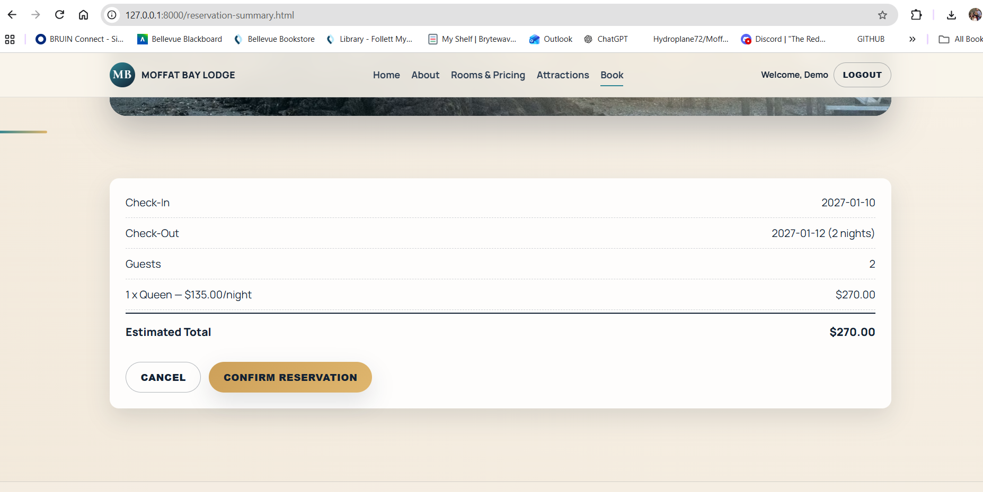
Comments | The reservation page successfully displayed available rooms and allowed the selected room to be added to the reservation. The page responded as expected throughout the test, and no functional issues were found. No correction was needed for this test.

Test 2: Insufficient Rooms Are Rejected
Test 2 | Insufficient Rooms Are Rejected
 | Test Objective: Verify that the reservation page prevents a user from adding more rooms than are available for the selected room type and dates. | Developer: Rashai Robertson  Date tested: 2026/09/10 | Peer tester: Tiffany Davidson  Date tested: <yyyy/mm/dd>
Step | Action | Expected results | Developer pass/fail | Tester pass/fail + Screenshot
1 | With MySQL and startup_api.py running, log in with the demo account and open reservation.html. | The reservation page loads and the reservation form is available to the logged-in user. | Pass | Pass  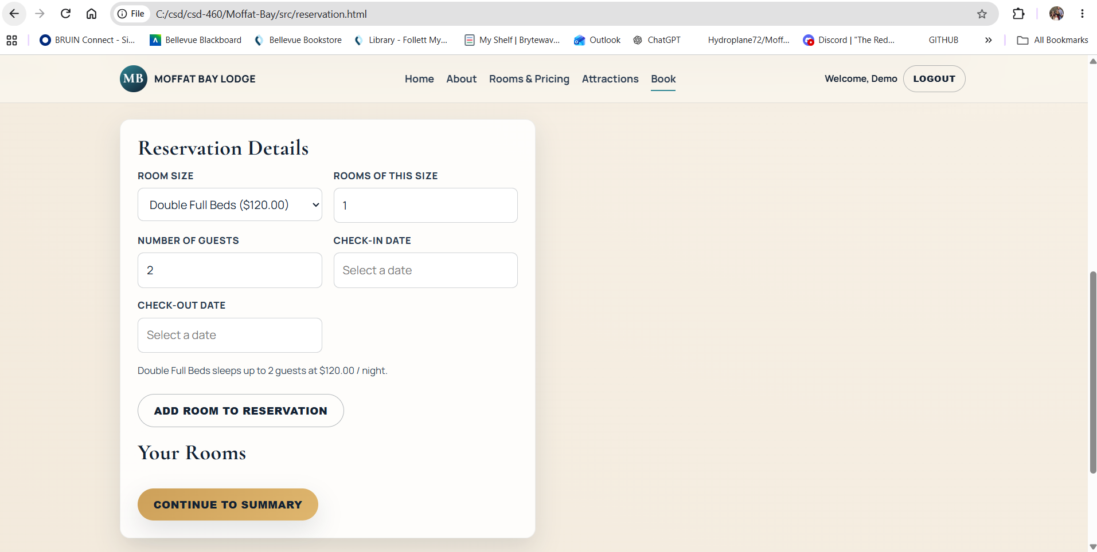
2 | Select Double Full Beds and set the room quantity to 5. | The page accepts the requested quantity for an availability check. | Pass | Pass  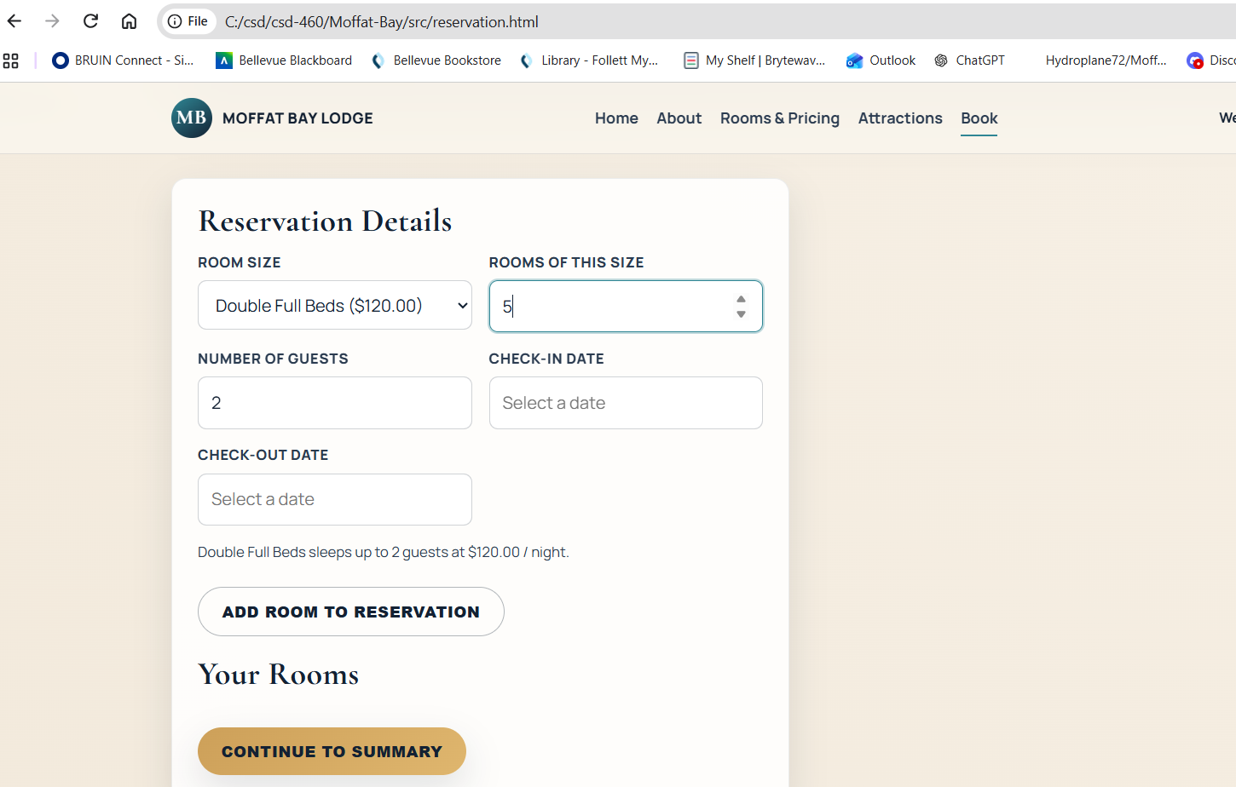
3 | Select a valid future stay such as 2027-01-10 through 2027-01-12 and keep the guest count at 2. | The future dates are accepted and the form is ready to check availability. | Pass | Pass  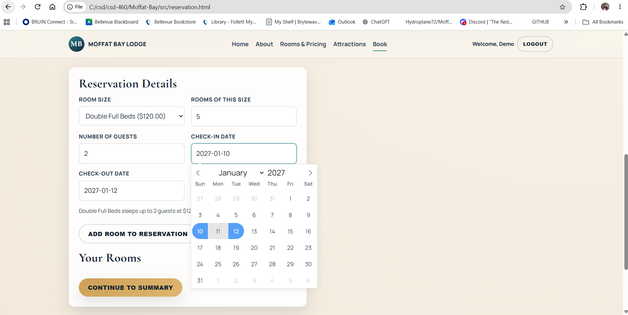
4 | Click “Add Room to Reservation.” | The backend determines there are not enough reservable Double Full Beds for the requested quantity. | Pass | Pass  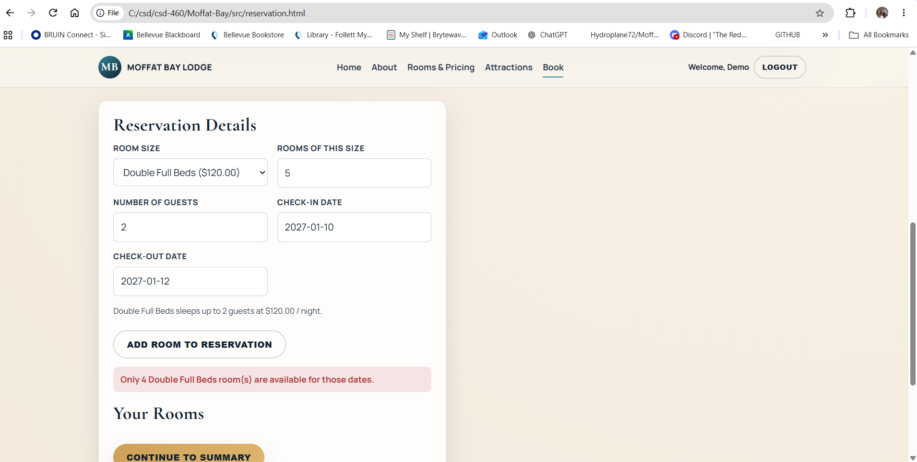
5 | Review the message and the Your Rooms cart. | A clear unavailable/not-enough-rooms message is shown and the unavailable request is not added to the reservation cart. | Pass | Pass  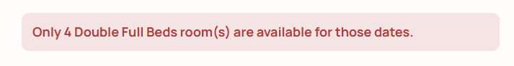
Comments | The reservation page correctly prevented the user from reserving more rooms than were available for the selected dates. The application displayed the appropriate availability behavior and did not allow an invalid reservation to continue. No correction was needed for the reservation logic.

Test 3: Reservation Creation Requires a Customer ID
Test 3 | Reservation Creation Requires a Customer ID
 | Test Objective: Verify that a logged-out visitor is blocked by the page and that a direct reservation API request without customer_id is rejected without creating a reservation. | Developer: Brayan Covarrubias  Date tested: 2026/09/11 | Peer tester: Tiffany Davidson  Date tested: <yyyy/mm/dd>
Step | Action | Expected results | Developer pass/fail | Tester pass/fail + Screenshot
1 | Log out, start `python src/api/startup_api.py` if needed, and open http://127.0.0.1:8000/reservation.html. | The page loads, the reservation form is hidden, and the “Before You Confirm” login/register panel is visible. | Pass | Pass  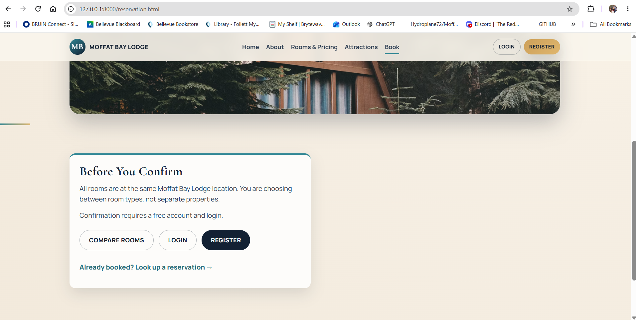
2 | Open DevTools Console and submit a POST request to /api/reservations without a customer_id using the test payload provided in ReservationPageFunctionalTests.md. | The request is sent directly to the backend, bypassing the front-end login gate. | Pass | Pass  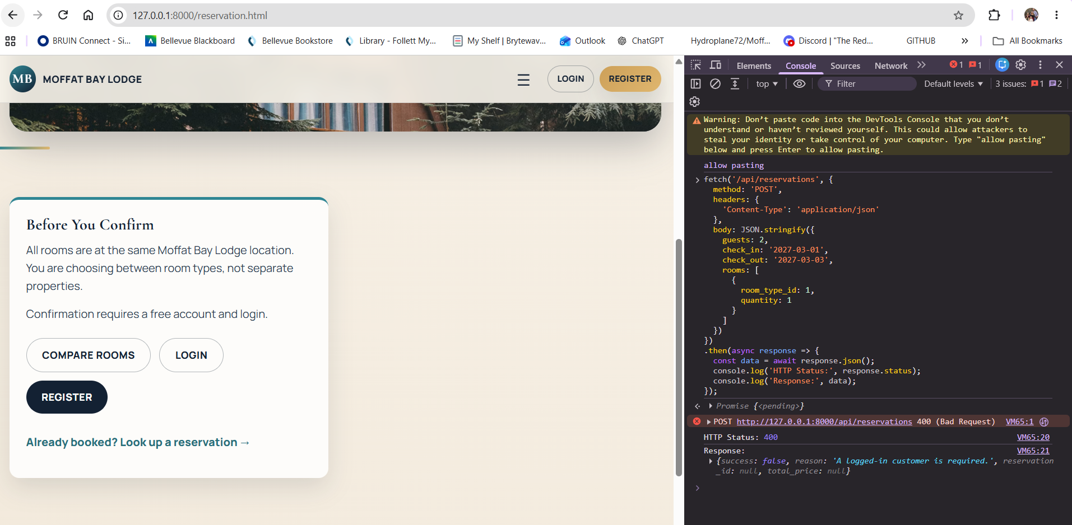
3 | Review the Console and Network response for the POST request. | The API returns HTTP 400 with success: false and a reason indicating that a logged-in customer is required. | Pass | Pass
4 | In MySQL, record the Reservations row count before and after the rejected request using `SELECT COUNT(*) FROM Reservations;`. | The row count is unchanged, confirming the rejected request did not create a reservation. | Pass | Pass  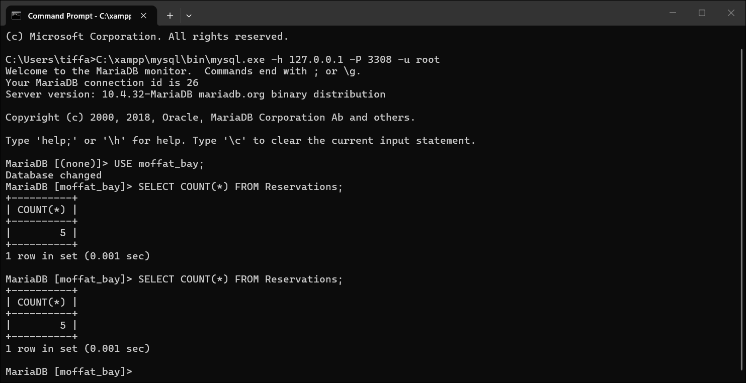
5 | Run `python -m pytest src/api/tests/test_reservation_api.py::test_create_reservation_requires_customer_id -v`. | The targeted FT-RES-03 automated test finishes with PASSED. | Pass | Pass  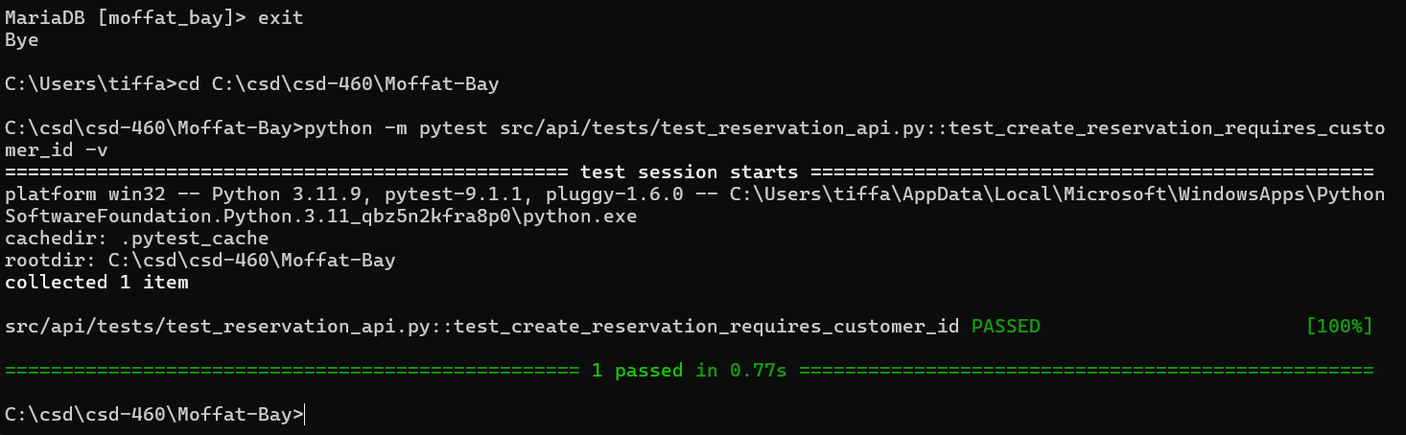
Comments | The application correctly required the user to be logged in before completing a reservation. During QA, the login initially failed because the local MySQL server was using a different port than the application expected. The issue was corrected by running the XAMPP database on port 3308 and updating the local database connection settings, after which the login function worked correctly.

Test 4: Reservation Creation Succeeds for Open Dates
Test 4 | Reservation Creation Succeeds for Open Dates
 | Test Objective: Verify that a complete valid reservation can be created end-to-end, transferred to the summary page, confirmed, and stored in Reservations and ReservationRooms. | Developer: Brayan Covarrubias  Date tested: 2026/09/11 | Peer tester: Tiffany Davidson  Date tested: <yyyy/mm/dd>
Step | Action | Expected results | Developer pass/fail | Tester pass/fail + Screenshot
1 | Open http://127.0.0.1:8000/login.html and log in with demo@moffatbay.com / DemoPass1. | Login succeeds and the reservation page opens for the demo customer. | Pass | Pass  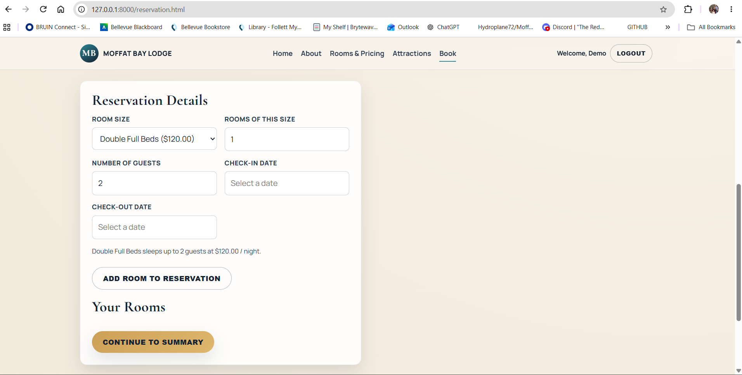
2 | Select 1 Queen room, 2 guests, and a far-future open stay such as 2027-04-01 through 2027-04-03. | The reservation inputs are accepted. | Pass | Pass  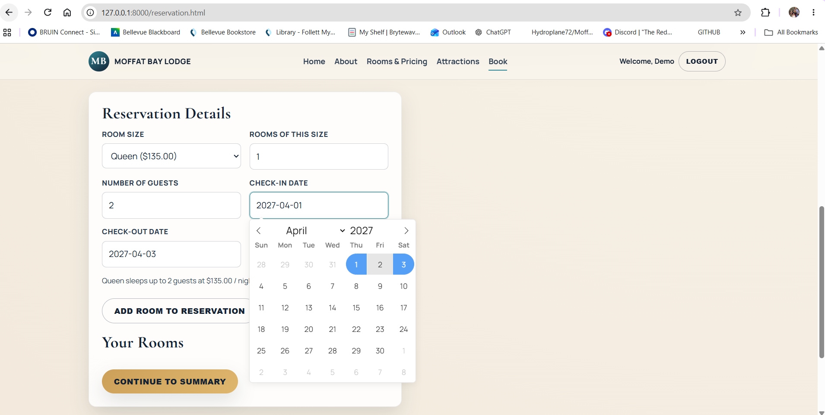
3 | Click “Add Room to Reservation.” | The selected Queen room is added to the cart as available. | Pass | Pass  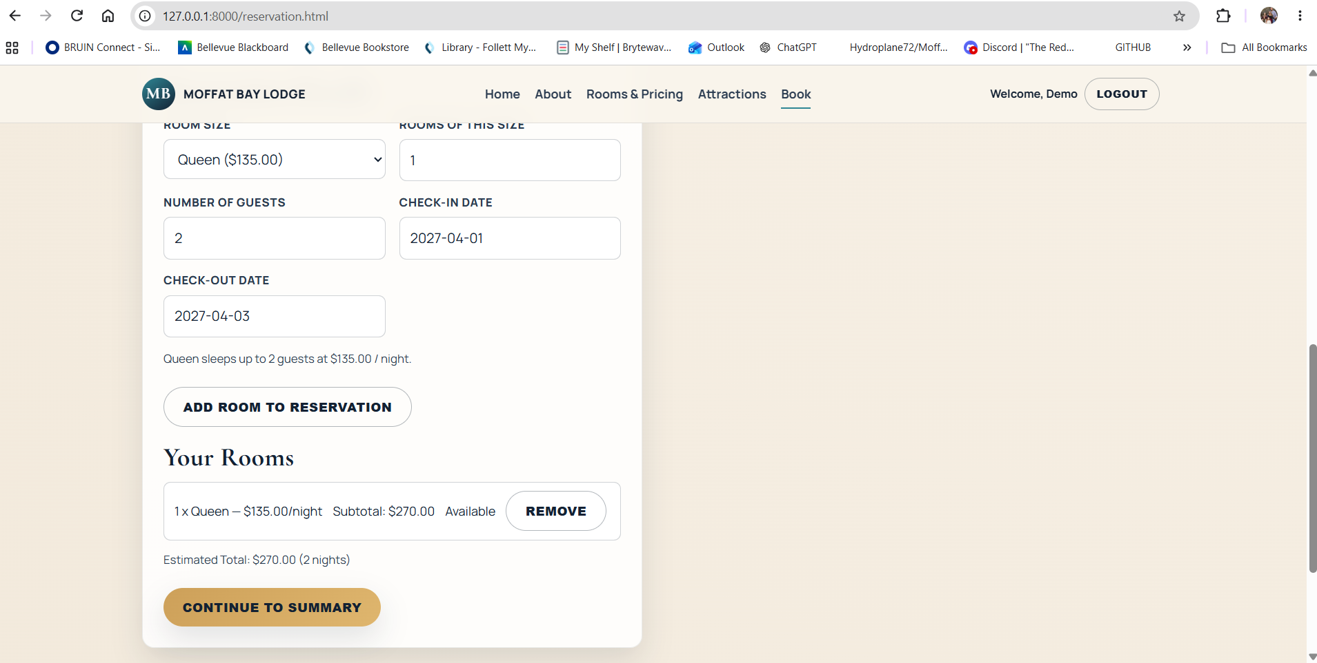
4 | Click “Continue to Summary.” | reservation-summary.html loads and shows the correct dates, guest count, room line item, number of nights, and estimated total. | Pass | Pass  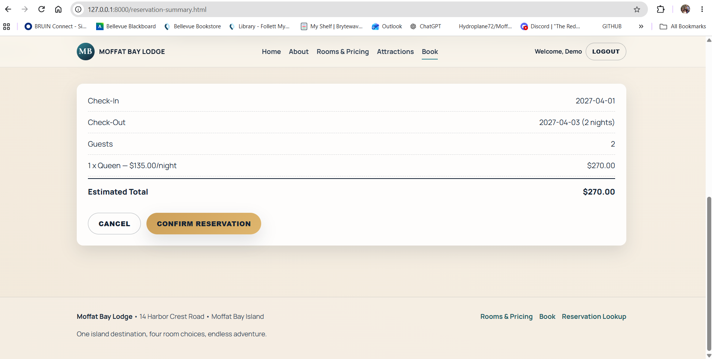
5 | Click “Confirm Reservation.” | A success message appears with “Reservation confirmed!” and a numeric confirmation number. | Pass | Pass  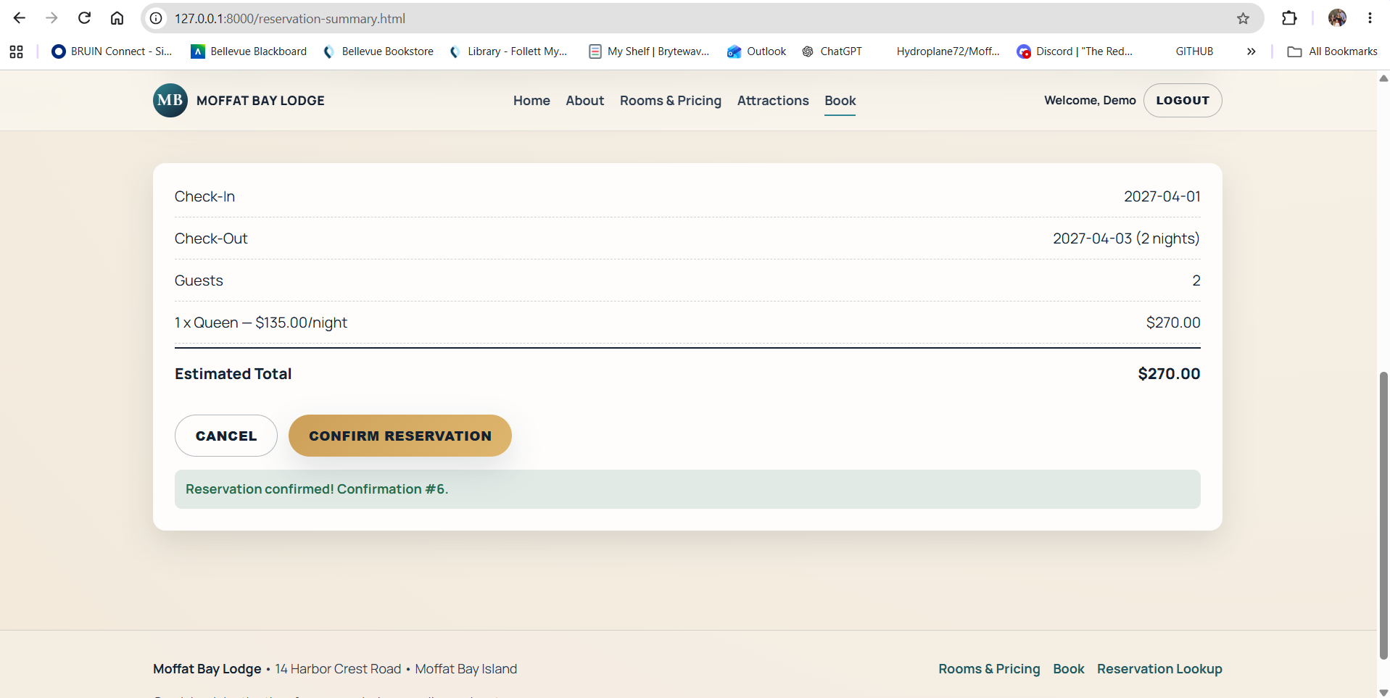
6 | In MySQL, query the newest reservation and its room using the Reservations and ReservationRooms tables. | A new confirmed Reservations row exists and a linked ReservationRooms row contains the room assigned to that reservation. | Pass | Pass  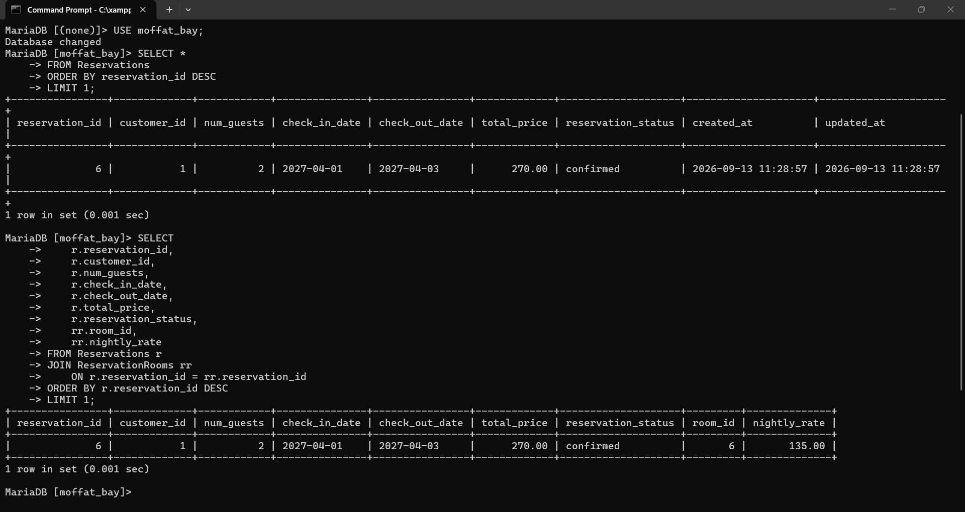
7 | Run `python -m pytest src/api/tests/test_reservation_api.py::test_create_reservation_succeeds_for_open_dates -v`. | The targeted FT-RES-04 automated test finishes with PASSED and returns a positive total price. | Pass | Pass  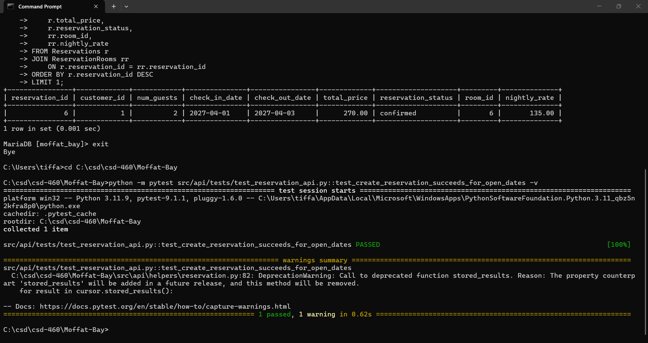
Comments | The complete reservation process worked as expected from room selection through the final confirmation page. The reservation information was carried through each step correctly and was successfully stored in the database. No additional correction was needed after the database connection was configured properly.

